As part of the DoE’s enterprise agreement with Adobe and Microsoft, students from Kindergarten to Year 12 can download and install AdobeCreative Cloud, MS Office and Windows for free.

Microsoft 365
The Microsoft package consists of Microsoft Office and Microsoft Windows 10. You can install Office on up to 5 x PCs or Macs, 5 x tablets, and 5 x smartphones. To get a copy of this free software, you must have a valid @education.nsw.gov.au student email address which is provided to every student enrolled in a NSW public school. If your child does not know their email address, please contact the class teacher.
Student portal: https://sso.det.nsw.edu.au/sso/UI/Login?goto=https://portal.det.nsw.edu.au/
Follow these steps to download Office:

1. Log into the student portal (see link above)
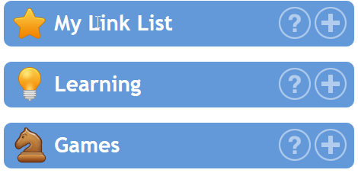

2. Select Microsoft Office 365
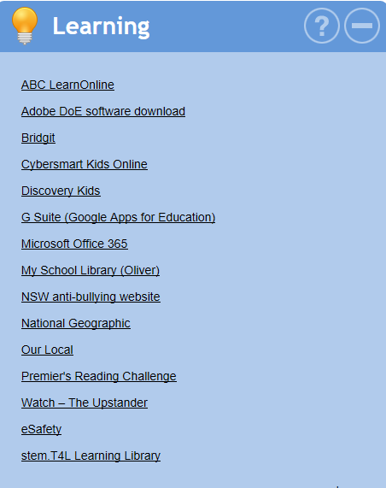

3. Click on the Install Office button and follow the directions
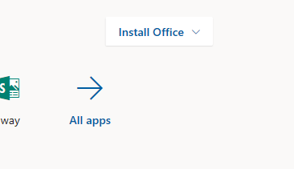

Adobe Creative Cloud download for students
As part of the DOE's Enterprise agreement with Adobe, students can download and install the Adobe Creative Cloud for free on one personally owned device.
Adobe Creative Cloud is a set of software applications that empower students to work with digital media such as photos, movies and websites. These are professional tools used widely in industry.
As part of this suite, the following software will be available to download:
- Photoshop and Photoshop Elements
- Illustrator
- InDesign
- Premiere Pro and Premiere Elements
- After Effects
- Dreamweaver
- and much more!
Refer to this webpage for instructions on how to obtain your free license to the Adobe Creative Cloud. Select Adobe DoE software download from the Learning menu in the student portal. This will take you to the NSW education On the Hub web store. Students will need to use their @education.nsw.gov.au student email address to register on their first visit.
Note: Individual students are eligible for one download per application only. You can also download Windows 10 and other software from this web store.
Click on this link for further information and instructions on accessing Adobe Creative Cloud: https://spark.adobe.com/page/8lGhJYYpqrrcb/ or view the video below for more instructions.
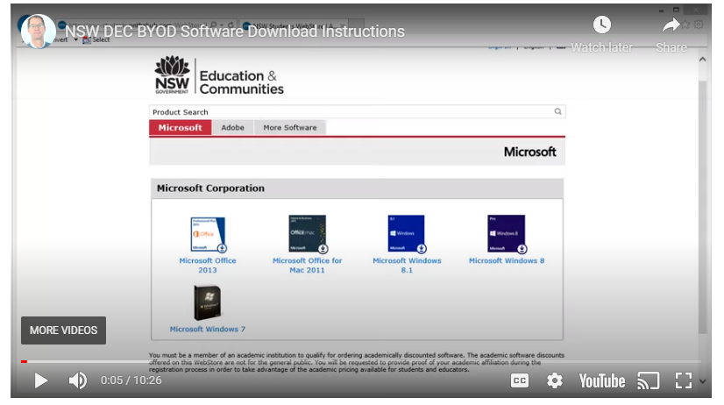
https://youtu.be/rK9DcAYmWEA

